**#1**

**Exercise 1: Configuring a Basic Spring Application**

**Scenario:**

Your company is developing a web application for managing a library. You need to use the Spring Framework to handle the backend operations.

**Steps:**

1. **Set Up a Spring Project:**
   * Create a Maven project named **LibraryManagement**.

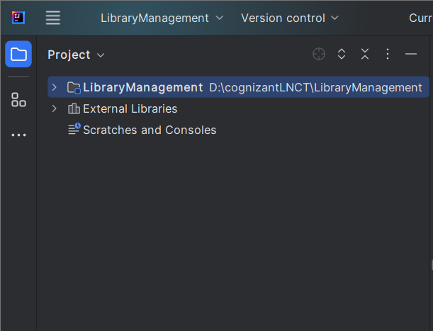

* + Add Spring Core dependencies in the **pom.xml** file.

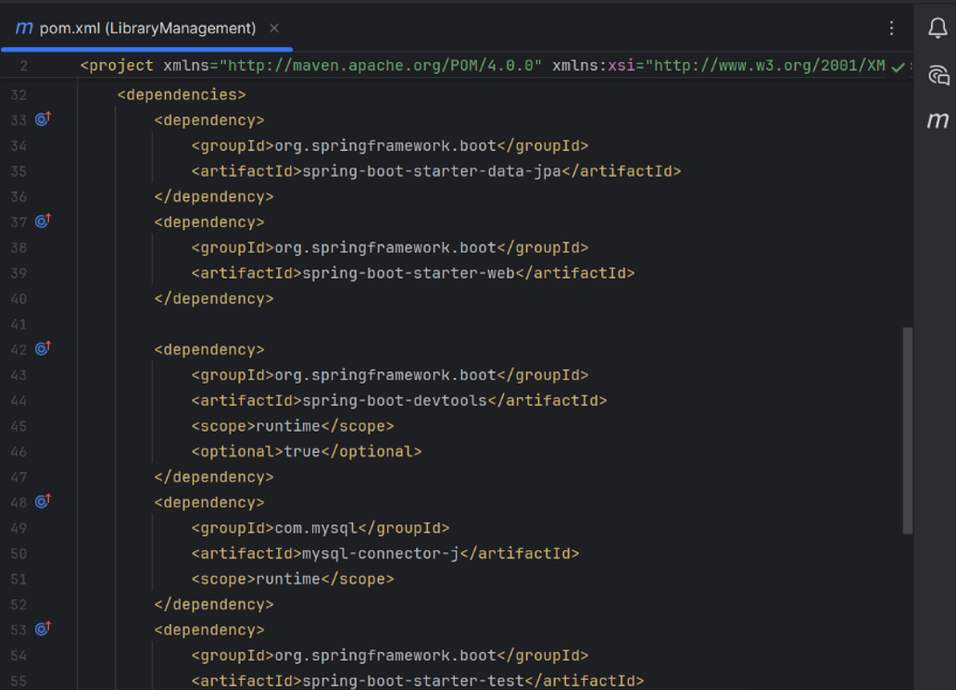

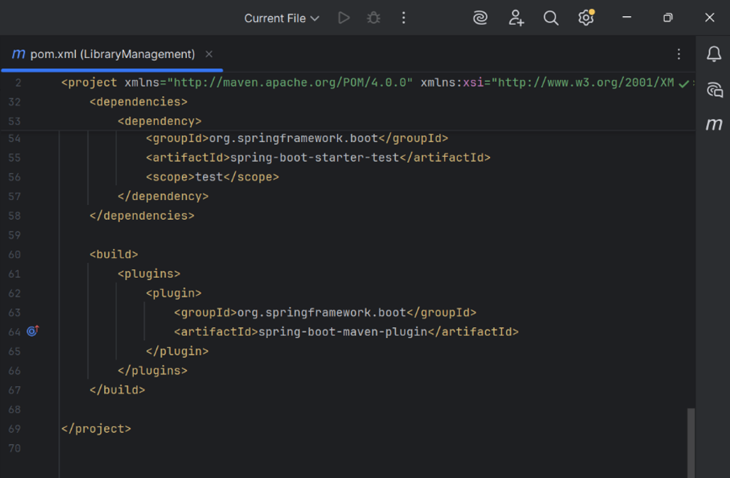

1. **Configure the Application Context:**
   * Create an XML configuration file named **applicationContext.xml** in the **src/main/resources** directory.
   * Define beans for **BookService** and **BookRepository** in the XML file.

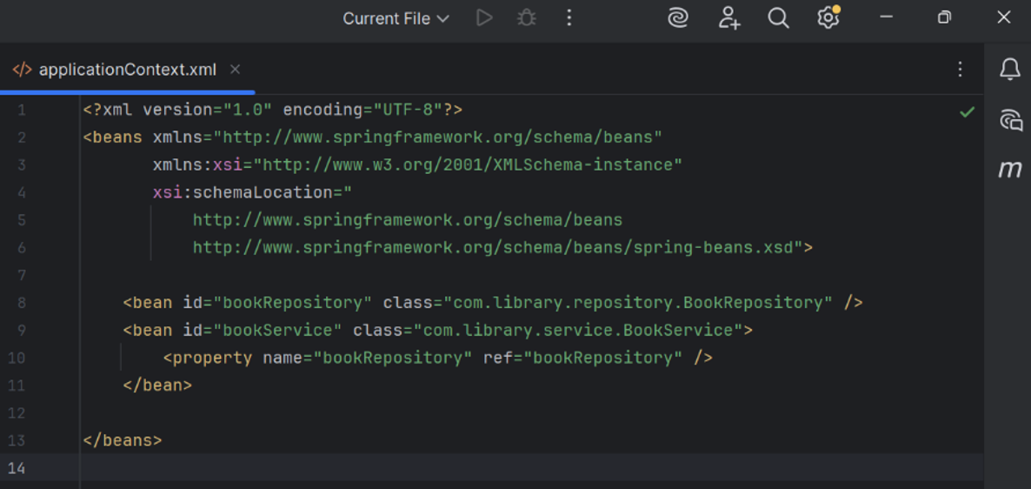

1. **Define Service and Repository Classes:**
   * Create a package **com.library.service** and add a class **BookService**.
   * Create a package **com.library.repository** and add a class **BookRepository**.

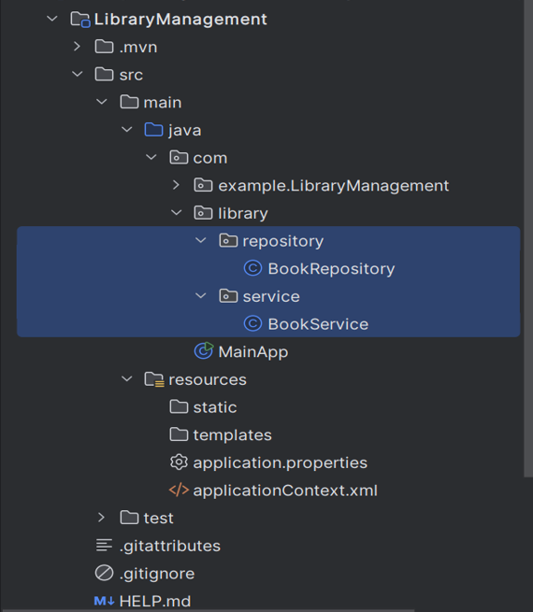

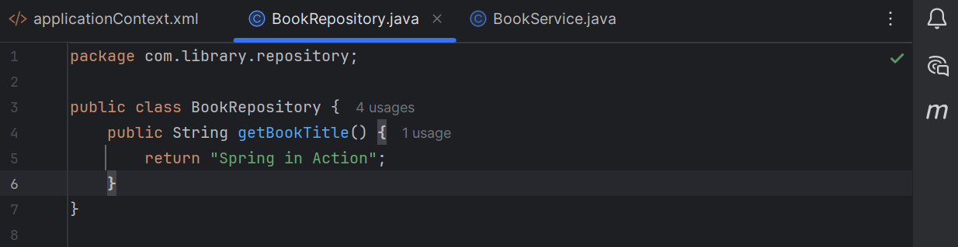

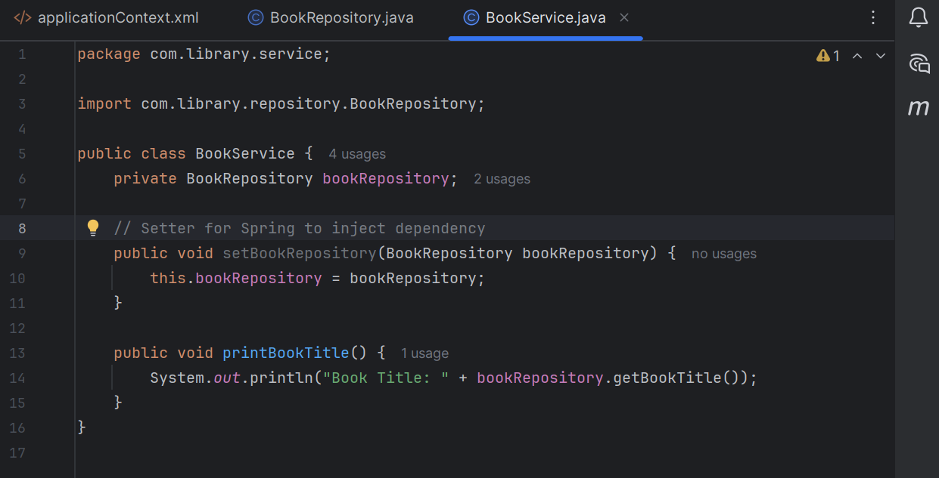

1. **Run the Application:**
   * Create a main class to load the Spring context and test the configuration.

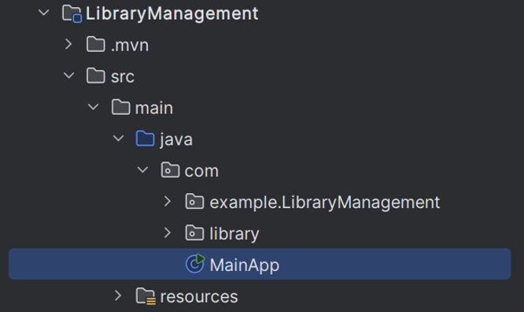

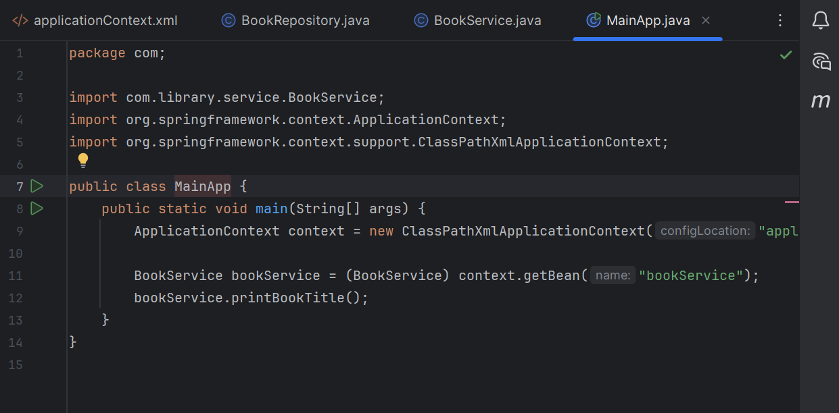

**OUTPUT:-**

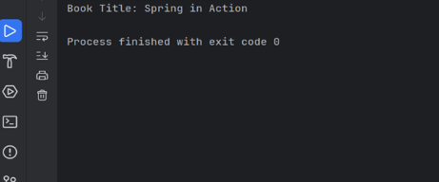

**#2**

**Exercise 2: Implementing Dependency Injection**

**Scenario:**

In the library management application, you need to manage the dependencies between the BookService and BookRepository classes using Spring's IoC and DI.

**Project Structure**

LibraryManagement/

**├── src/**

**│ ├── main/**

**│ │ ├── java/**

**│ │ │ └── com/**

**│ │ │ └── library/**

**│ │ │ ├── MainApp.java**

**│ │ │ ├── repository/**

**│ │ │ │ └── BookRepository.java**

**│ │ │ └── service/**

**│ │ │ └── BookService.java**

**│ │ └── resources/**

**│ │ └── applicationContext.xml**

**└── pom.xml**

**Steps:**

1. **Modify the XML Configuration:**
   * Update **applicationContext.xml** to wire **BookRepository** into **BookService**.

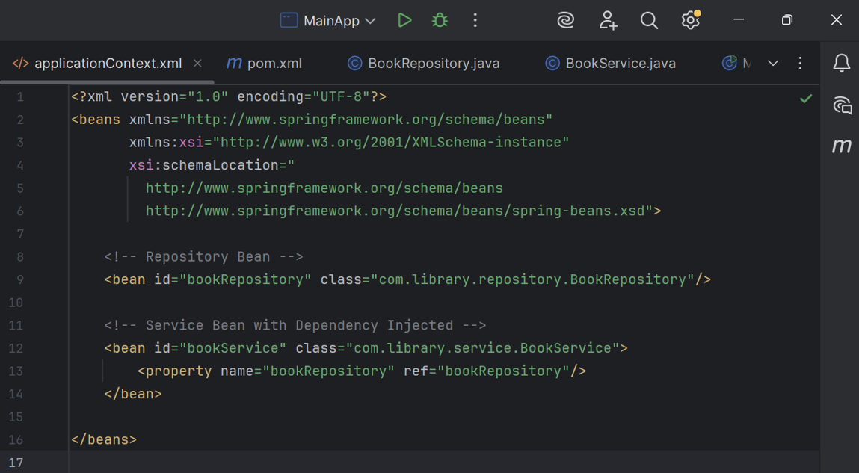

1. **Update the BookService Class:**
   * Ensure that **BookService** class has a setter method for **BookRepository**

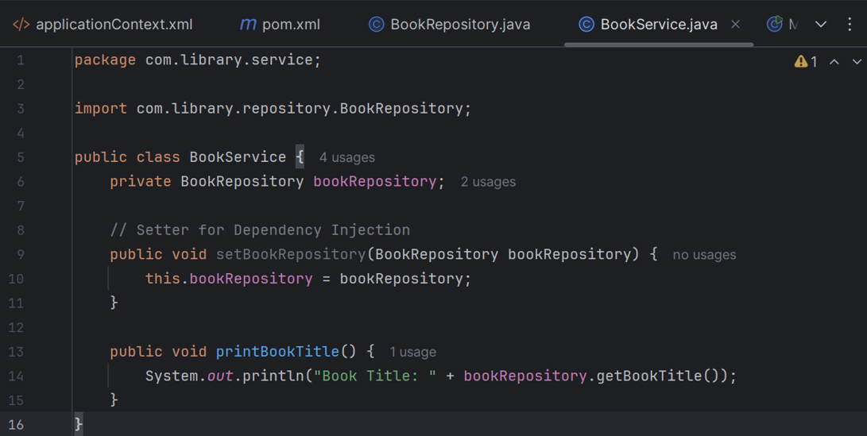

1. **Test the Configuration:**
   * Run the **LibraryManagementApplication** main class to verify the dependency injection.

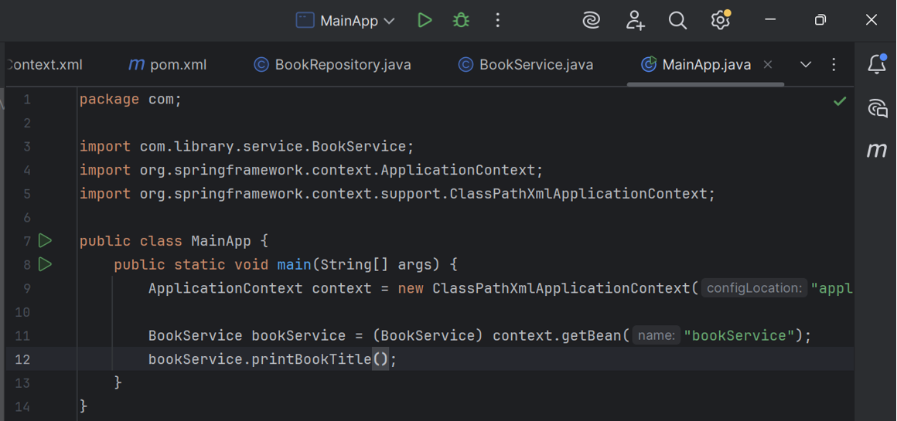

**OUTPUT:-** 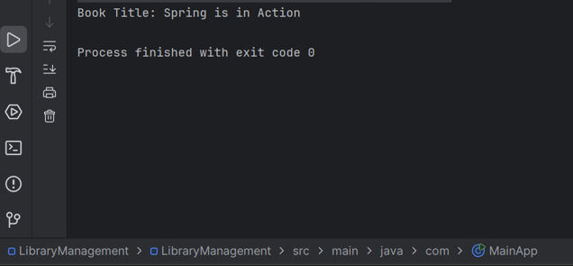

**#3**

**Exercise 4: Creating and Configuring a Maven Project**

**Scenario:**

You need to set up a new Maven project for the library management application and add Spring dependencies.

**Steps:**

1. **Create a New Maven Project:**
   * Create a new Maven project named **LibraryManagement**.
2. **Add Spring Dependencies in pom.xml:**
   * Include dependencies for Spring Context, Spring AOP, and Spring WebMVC.

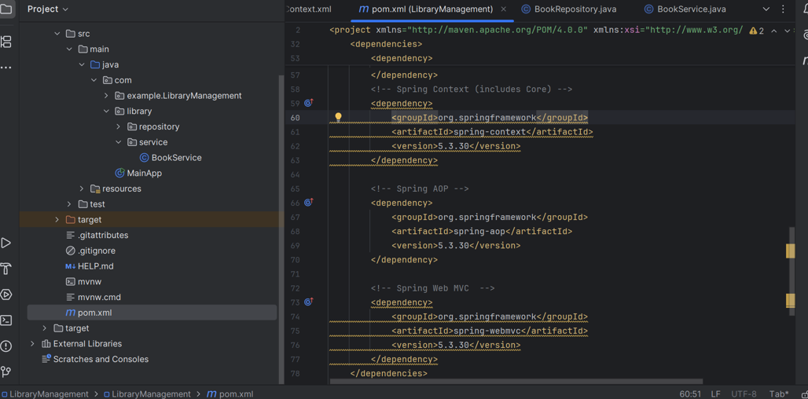

1. **Configure Maven Plugins:**
   * Configure the Maven Compiler Plugin for Java version 1.8 in the pom.xml file.

